Task 6



Name: Matthew Kamal Saad

Submitted to: Eng. Ahmed Saber & Eng. Ali elsese
Date: 26/10/2025

Table of Contents

Introduction 3
Difference between box shadow & drop shadow 3
Box Shadow 4
Syntax & Parameters 4
Examples 5

Drop Shadow 6
Definiation 6
Examples 6
References 7

Introduction

Difference Between Box Shadow and Drop Shadow:
Box Shadow:
Applies to: The entire rectangular box model of an HTML element (e.g., div, button, p).
Shape: Creates a shadow that follows the rectangular boundaries of the element's box, regardless of any transparency within the element's content.
CSS Property: Implemented using the box-shadow CSS property.
Use Cases: Ideal for creating shadows on block-level elements like cards, buttons, containers, and other rectangular UI components.

Drop Shadow:
Applies to: The visible content of an element, respecting its alpha channel (transparency).
Shape: Creates a shadow that conforms to the actual, non-rectangular shape of the content within the element, even if the element itself has a rectangular box model. This is especially useful for images with transparent backgrounds (like PNGs), icons, or SVGs.
CSS Property: Implemented using the filter: drop-shadow() CSS function.
Use Cases: Best for adding shadows to transparent images, logos, icons, or any element where the shadow should follow the contours of the visible content rather than the bounding box.
Box Shadow
Syntax:
box-shadow: (horizontal-offset) (vertical-offset) (blur-radius) (spread-radius) (color);

Parameters:
Horizontal offset (Required):
- Specifies the horizontal distance of the shadow from the element.
- Positive values move the shadow to the right; negative values move it to the left.
Vertical offset (Required):
- Specifies the vertical distance of the shadow from the element.
- Positive values move the shadow downwards.
- negative values move it upwards.
Blur-radius (Optional):
- Defines the blurriness of the shadow.
- A value of 0 results in a sharp shadow.
- Higher values create a more diffused, blurred shadow.
- Negative values are not allowed.
Spread radius (Optional):
- Adjust the size of the shadow.
- Positive values expand the shadow in all directions.
- Negative values contract the shadow.
- The default value is 0, meaning the shadow's size is determined by the blur radius.

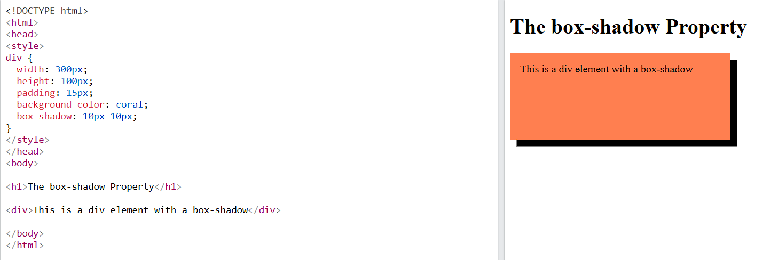
Examples:

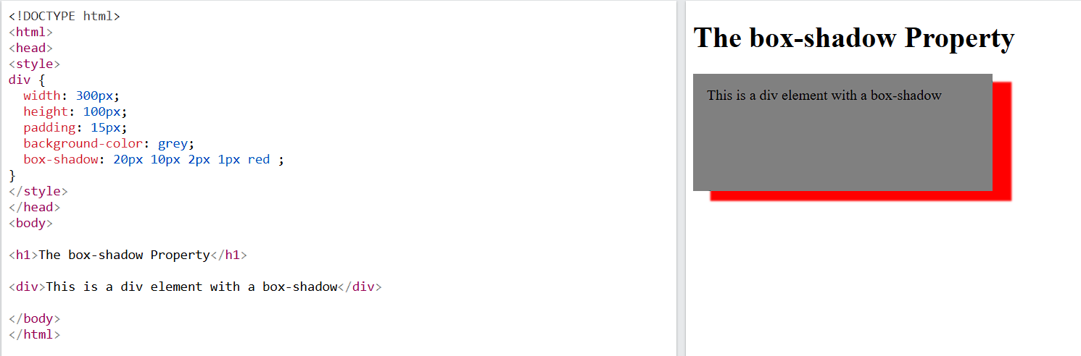

Drop Shadow (via filter)
Definition:
- Follows the visible shape of the element (non-rectangular or transparent areas).
- Great for images, PNGs, and SVGs with transparent backgrounds.

Examples:
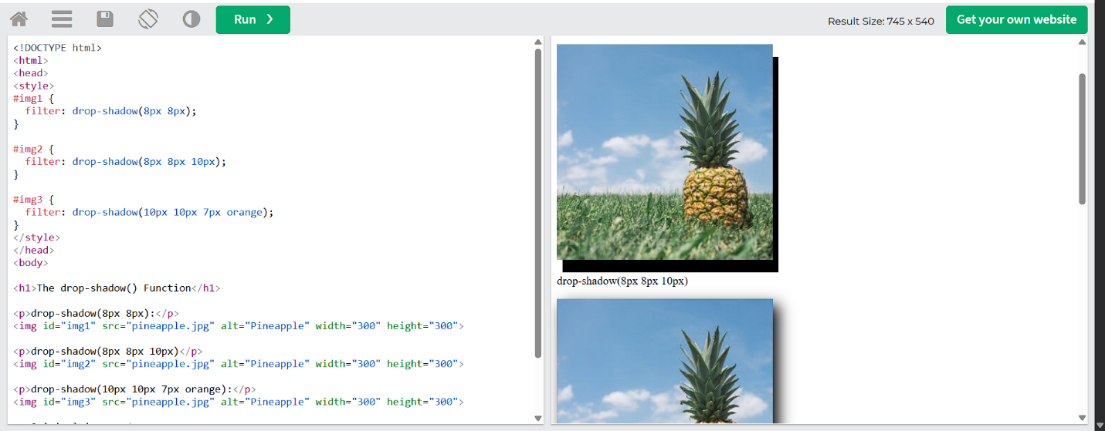

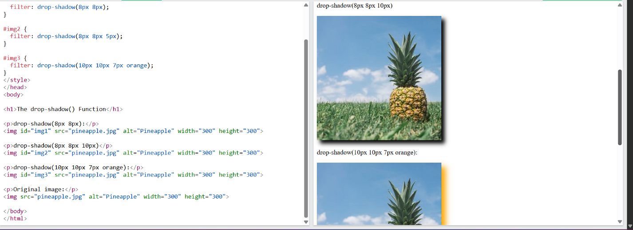

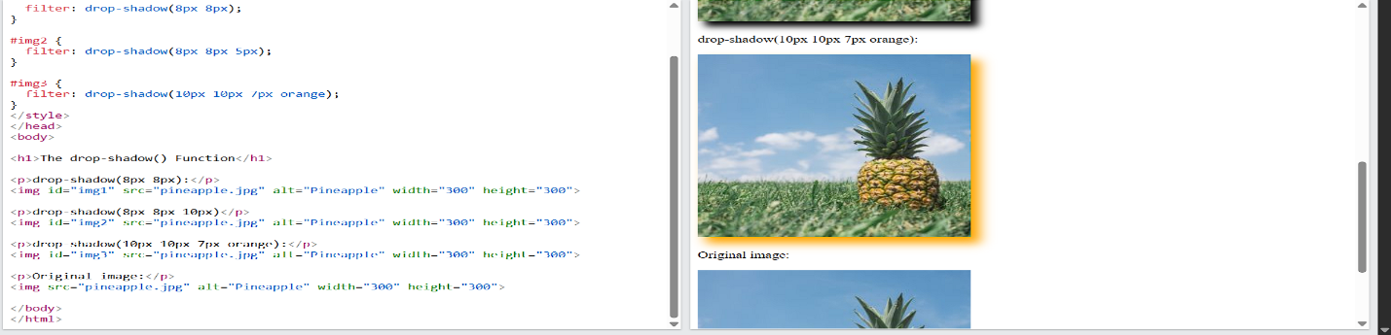
References

- https://www.w3schools.com

